**Q-3) Create table below : salesperson and customer:**

Query:-

1. *Creating table salesperson:*

create table salesperson (s_no int primary key, s_name varchar(50), city varchar(50), commision decimal(10,2));

1. *Inserting data into table salesperson*:

INSERT INTO `salesperson`(`s_no`, `s_name`, `city`, `commision`)

VALUES

('1001', 'Peel', 'London', '0.12'),

('1002', 'Serres', 'San Jose', '0.13'),

('1004', 'Motika', 'London', '0.11'),

('1007', 'Rafkin', 'Barcelona', '0.15'),

('1003', 'Axelrod', 'New York', '0.10');

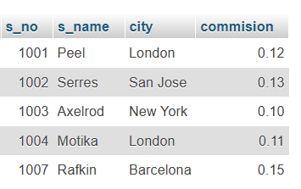

1. *Creating table customer*:

create table customer (c_nm int primary key, c_name varchar(50), city varchar(50),

rating int, s_no int, foreign key(s_no) REFERENCES salesperson(s_no));

1. *Inserting data into table customer*:

INSERT INTO `customer`(`c_nm`, `c_name`, `city`, `rating`, `s_no`)

VALUES

('201', 'Hoffman', 'London', '100', '1001'),

('202', 'Giovanne', 'Rome', '200', '1003'),

('203', 'Liu', 'San Jose', '300', '1002'),

('204', 'Grass', 'Barcelona', '100', '1002'),

('206', 'Clemens', 'London', '300', '1007'),

('207', 'Pereira', 'Rome', '100', '1004');

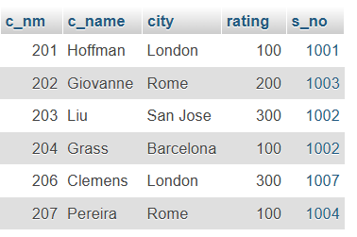

1. *Names and cities of all salespeople in London with commission above 0.12*:

Query:-

Select s_name, city from salesperson where city = ‘London’ and commission > 0.12;

--no output because there is no data where city is London and commission is above 0.12

1. *All salespeople either in Barcelona or in London*:

Query:-

SELECT * FROM `salesperson` WHERE city = 'Barcelona' or city = 'London';

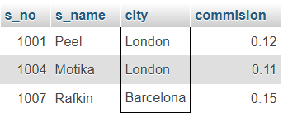

1. *All salespeople with commission between 0.10 and 0.12*:

Query:-

SELECT * FROM `salesperson` WHERE commission > 0.10 and commision < 0.12;

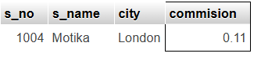

1. *All customers whose rating <= 100 unless they are located in Rome*:

Query:-

SELECT * FROM `customer` WHERE rating <= 100 or city = 'Rome';

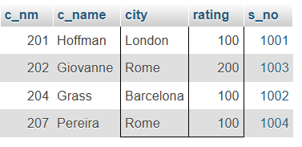

**Q-4) Write a SQL statement that displays all the information about all salespeople:**

Query:-

1. *Creating the table salesman*:

create table salesman (salesman_id int, name varchar(50), city varchar(50), commission decimal(4,2));

1. *Inserting values in table salesman*:

INSERT INTO salesman (salesman_id, name, city, commission)

VALUES

(5001, 'James Hoog', 'New York', 0.15),

(5002, 'Nail Knite', 'Paris', 0.13),

(5005, 'Pit Alex', 'London', 0.11),

(5006, 'Mc Lyon', 'Paris', 0.14),

(5007, 'Paul Adam', 'Rome', 0.13),

(5003, 'Lauson Hen', 'San Jose', 0.12);

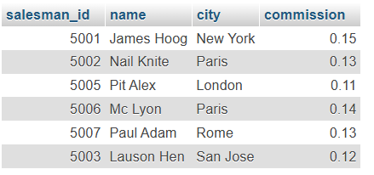

1. *Displaying all the information about all sales people*:

Select * from salesman;



**Q-5) From the following table, write a SQL query to find orders that are delivered by a salesperson with ID. 5001. Return ord_no, ord_date, purch_amt:**

Query:-

1. *Creating the sample table order*:

CREATE TABLE orders (ord_no INT, purch_amt DECIMAL(10, 2), ord_date DATE, customer_id INT, salesman_id INT);

1. *Inserting values into table orders*:

INSERT INTO orders (ord_no, purch_amt, ord_date, customer_id, salesman_id)

VALUES

(70001, 150.50, '2012-10-05', 3005, 5002),

(70009, 270.65, '2012-09-10', 3001, 5005),

(70002, 65.26, '2012-10-05', 3002, 5001),

(70004, 110.50, '2012-08-17', 3009, 5003),

(70007, 948.50, '2012-09-10', 3005, 5002),

(70005, 2400.60, '2012-07-27', 3007, 5001),

(70008, 5760.00, '2012-09-10', 3002, 5001),

(70010, 1983.43, '2012-10-10', 3004, 5006),

(70003, 2480.40, '2012-10-10', 3009, 5003),

(70012, 250.45, '2012-06-27', 3008, 5002),

(70011, 75.29, '2012-08-17', 3003, 5007),

(70013, 3045.60, '2012-04-25', 3002, 5001);

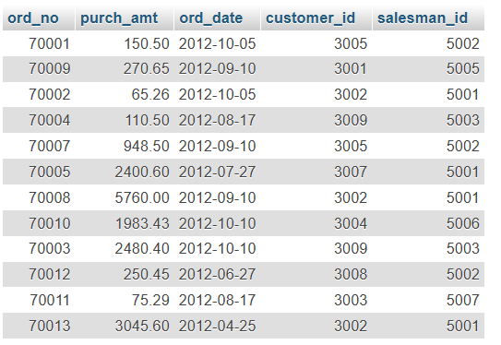

1. *Finding orders that are delivered by the salesman with id 5001, returning only ord_date, ord_no, purch_amt*:

SELECT `ord_no`, `ord_date`, `purch_amt` FROM `orders` WHERE salesman_id = 5001;

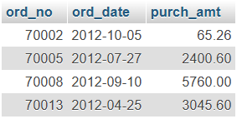

**Q-6) From the following table, write a SQL query to select a range of products whose price is in the range Rs.200 to Rs.600. Begin and end values are included. Return pro_id, pro_name, pro_price, and pro_com.**

Query:-

1. *Creating table item_mast*;

CREATE TABLE item_mast (pro_id INT, pro_name VARCHAR(50), pro_price DECIMAL(10, 2), pro_com INT);

1. *Inserting data into table item_mast*:

INSERT INTO item_mast (pro_id, pro_name, pro_price, pro_com)

VALUES

(101, 'Mother Board', 3200.00, 15),

(102, 'Key Board', 450.00, 16),

(103, 'ZIP drive', 250.00, 14),

(104, 'Speaker', 550.00, 16),

(105, 'Monitor', 5000.00, 11),

(106, 'DVD drive', 900.00, 12),

(107, 'CD drive', 800.00, 12),

(108, 'Printer', 250.00, 13),

(109, 'Refill cartridge', 350.00, 13),

(110, 'Mouse', 250.00, 12);

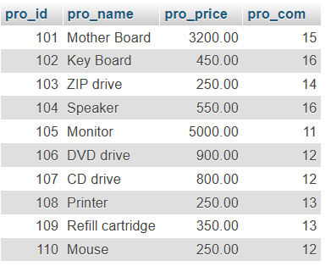

1. *select a range of products whose price is in the range Rs.200 to Rs.600. Begin and end values are included. Return pro_id, pro_name, pro_price, and pro_com*:

SELECT pro_id, pro_name, pro_price, pro_com FROM item_mast WHERE pro_price BETWEEN 200 AND 600;

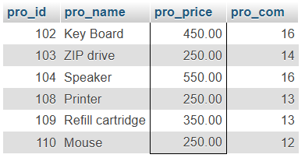

1. *From the following table, write a SQL query to calculate the average price for a manufacturer code of 16. Return avg*:

SELECT avg(pro_price) as avg_price FROM `item_mast` WHERE pro_com = 16;

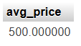

1. *From the following table, write a SQL query to display the pro_name as 'Item Name' and pro_priceas 'Price in Rs.'*:

SELECT pro_name as item_name, pro_price as price_in_rs from item_mast;

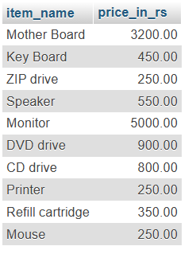

1. *From the following table, write a SQL query to find the items whose prices are higher than or equal to $250. Order the result by product price in descending, then product name in ascending. Return pro_name and pro_price*:

SELECT pro_name, pro_price FROM `item_mast` WHERE pro_price >= 250 order by pro_price desc, pro_name asc;

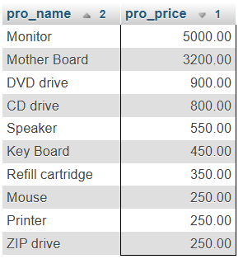

1. *From the following table, write a SQL query to calculate average price of the items for each company. Return average price and company code*:

SELECT pro_com, avg(pro_price) as avg_price FROM `item_mast` group by pro_com;

